NEWSLETTER
Silver State Chapter July 2019

Chapter Officers  Suzanne Valdez  President  sl2485@att.com  David Collier  Vice President  dc1787@att.com  Billie Augustine  Member at Large  ba5289@att.com  Janice Ono  Member at Large  jo5243@att.com  Sharon Jaramillo  Member at Large  sj1649@att.com  Patti Rose, President  Carson Area Life Member Club  775-882-5205  Sheryl Stopper  Life Member Representative sherylstopper@gmail.com  Larry Gibbs  Immediate Past President  lg7427@att.com  Treasurer  Kris Wells  kw2734@att.com  Secretary  Beth Freemont  mf2598@att.com  Have an idea for a  Pioneers Project???  Contact:  Suzanne Valdez, sl2485@att.com | Silver State Chapter Website:  http://west-region.attpioneers.org/chapter101/  Please visit the link and send feedback about the site to any of the Chapter Officers shown to the left:  CELL PHONES FOR RECYCLE PROJCT  Cell Phones for Recycle is an environmental project; after all expenses for the program are handled, the remaining funds are donated to Cell Phones for Soldiers for our troops.  Contact: Kathy Dornstauder,  e-mail: kd7138@att.com  Phone: 775-683-5284  Pioneer Retirees in Southern Nevada  Contact Fred Hampton for  Volunteering Events, Projects and Opportunities  Email: fredhampton89@gmail.com  or call: 505-401-2298  Silver State Chapter #101  Wednesday, July 17, 2019  Bring your ideas for projects!!!  10:00 – 11:00 AM by conference call  Suzanne Valdez, sl2485@att.com  Carson Area Life Member Club  White Elephant Auction rescheduled  Mom & Pop’s Diner  Carson City, NV  Tuesday, July 16, 2019 1:00 PM  Order from the Menu  CONTACT: Patti Rose, 775-885-5205  Silver Sage Social Club  Wednesday, July 10, 2019  Louis’ Basque Corner  East 4th Street, Reno, NV.  11:30 AM – 1:30 PM  Contact: Jackie Boyden, 775-813-4593 (for this meeting only.)  $23.00, includes tax and tip  HAVE A GOOD TIME!!! ENJOY GREAT FOOD and GOOD FRIENDS!!!!

From:
AT&T Pioneers Silver State Chapter #101
5250 S Virginia St., Suite 200, Rm 204
Reno, NV 89502

RETURN SERVICE REQUESTED
Date Sensitive Material Please Open
July 2019 Newsletter

PRSRT STD
U.S. POSTAGE PAID
RENO NV
PERMIT NO. 40

If you would like
to receive newsletter
electronically, please
send your request by
e-mail to mf2598@att.com

___ ___

Education Benefits

Visit these Education Programs:
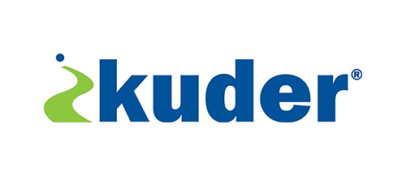
Pioneers receive a 25% discount on any of the following online career and education planning programs from Kuder: Kuder® Journey for adults, Kuder® Navigator for middle school and high school students, and Kuder® Galaxy for elementary students. More information at this link: https://www.kuder.com/
Questions? Contact Kuder at 1-800-314-8972

For School Supplies
Office Depot and OfficeMax are now one company! Telecom Pioneers Members can save up to 80% on over 93,000 products. Great for back to school, printing, cleaning and office needs. Shop online or in any
Office Depot or OfficeMax store.

Check these travel benefits for Pioneers Members

Emergency Assistance Plus (EA+)
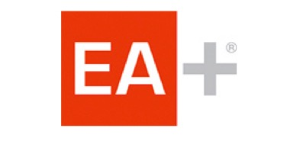
Emergency medical transportation services.
Benefits to Members:
- 24/7 medical evacuation, transportation services, and travel assistance when you travel 50+ miles from home
- Guaranteed acceptance
- Simple application process
- Low group rates offered
Call toll-free 1-855-842-3277

Car Rental Choices:

Hertz Car Rental
Everyday savings of up to 25% off when reserving with Pioneer organization’s CDP# 2150191 for either business or leisure travel.
call 1-800-654-2200 to enroll now

OR

Dollar Rental Car
Save 7% off base rates at participating locations.
To make a reservation call 1-800-800-4000 (Use CDP# 3061726)

