|  |  |
| --- | --- |
| newcolorvertical | NEWSLETTER  Silver State Chapter October 2019 |

|  |  |
| --- | --- |
| Chapter Officers  Suzanne Valdez  President  [sl2485@att.com](mailto:sl2485@att.com)  David Collier  Vice President  [dc1787@att.com](mailto:dc1787@att.com)  Billie Augustine  Member at Large  [ba5289@att.com](mailto:ba5289@att.com)  Janice Ono  Member at Large  [jo5243@att.com](mailto:jo5243@att.com)  Sharon Jaramillo  Member at Large  [sj1649@att.com](mailto:sj1649@att.com)  Patti Rose, President  Carson Area Life Member Club  775-882-5205  Sheryl Stopper  Life Member Representative sherylstopper@gmail.com  Larry Gibbs  Immediate Past President  lg7427@att.com  Treasurer  Kris Wells  [kw2734@att.com](mailto:kw2734@att.com)  Secretary  Beth Freemont  [mf2598@att.com](mailto:mf2598@att.com)  Have an idea for a  Pioneers Project???  Contact:  Suzanne Valdez, [sl2485@att.com](mailto:sl2485@att.com) | Silver State Chapter Website:  <http://west-region.attpioneers.org/chapter101/>  Please visit the link, the send feedback to any of the Chapter Officers  Pioneer Retirees in Southern Nevada  Contact Fred Hampton for  Volunteering Events, Projects and Opportunities  Email: [fredhampton89@gmail.com](mailto:fredhampton89@gmail.com)  Silver State Chapter #101 or call: 505-401-2298  Wednesday, October 16, 2019  Bring your ideas for projects!!!  10:00 – 11:00 AM by conference call  Suzanne Valdez, [sl2485@att.com](mailto:sl2485@att.com)  Carson Area Life Member Club  Red’s Old 395 Grill, Carson City, NV  Tuesday, October 15, 2019 1:00 PM  Silent Auction  Donations: Please Bring Pet Food and/or  Socks  CONTACT: Patti Rose, 775-882-5205  Save The Date!!!  December 17, 2019  Christmas Party  Dinner Meeting  Silver Sage Social Club  Wednesday, October 9, 2019  Louis’ Basque Corner  East 4th Street, Reno, NV.  11:30 AM – 1:30 PM Bob Porter: 775-826-2424  $23.00, includes tax and tip  BBB Secure Your ID Day  Saturday, October 19, 2019 8:30 AM  New Location: West Parking lot of the Atlantis Casino Resort  3800 South Virginia Street, Reno, NV  Secure Your ID Day is a free event where you can safely and securely dispose of unneeded personal documents. Mobile shredding trucks will be on-site accepting up to three (3) boxes or bags of unwanted documents to shred. Volunteers will help collect food donations for the Food Bank of Northern Nevada and assist with traffic control and providing information to people dropping off their material for shredding.  Contact: Janice Ono, 775-333-3991  See Next page |

**Many people have been asking about another Nevada Bell reunion. A few people have considered it and decided to pull together a more casual event than those in past years. Please share this post with all your NB and AT&T contacts! We will gather on Oct 12, 2019, at the Occidental Tap House Grill at Baldini’s Casino 865 S. Rock Blvd, Sparks**

**Happy Hour Daily 4PM-7PM**

**$3 Craft Beer Pints\***

**Plus discounted appetizer pricing**

Space is limited to about 150 so they’ve asked us to provide a headcount.

Please RSVP by Oct 1, 2019 via email to [cevande@aol.com](mailto:cevande@aol.com) or phone 775-747-7848.

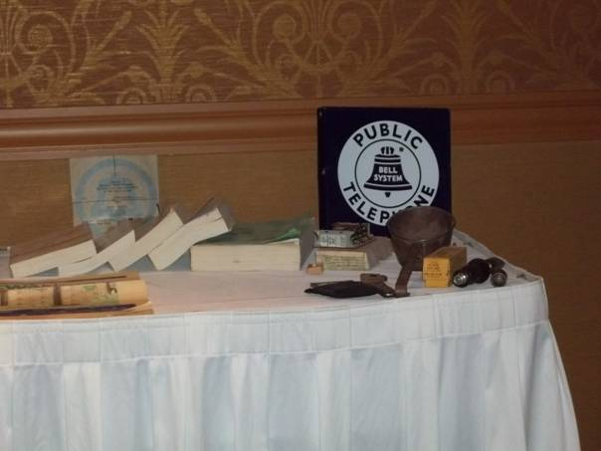

KTMB Adopt-A-Spot Clean Up

Tuesday, October 8, 2019

3:30 – 4:30 PM

Silver State Chapter Pioneers

Adopted Spot on Longley Lane

Btwn Air Center Circle &Nevada Humane Society

Contact:

Beth Freemont,

[mf2958@att.com](mailto:mf2958@att.com) or

775-683-5225

CELL PHONES FOR RECYCLE PROJECT

Cell phones for Recycle is an on-going project,

To keep unwanted/unused cell phones out of Landfills

After expenses for the program are handled, the remaining funds

are donated to Cell Phones for Soldiers.

Collection Bins are located in the Breakroom, 5250 S. Virginia St Office

Contact: Kathy Dornstauder,

e-mail: [kd7138@att.com](mailto:kd7138@att.com)