NEWSLETTER
Silver State Chapter September 2021
ANSWERING THE CALL OF THOSE IN NEED

Chapter Officers  David Collier  President  dc1787@att.com  Gary Marsh  Vice President  gm517f@att.com  Billie Augustine  Member at Large  ba5289@att.com  John Frank  Member at Large  jf1519@att.com  Jacqueline Boyden  Life Member Representative  775-813-4593  jacquelinek64@att.net  Suzanne Valdez  Immediate Past President  sl2485@att.com  Treasurer  Kris Wells  kw2734@att.com  Secretary  Beth Freemont  mf2598@att.com  Have an idea for a  Pioneers Project???  Contact:  David Collier, dc1787@att.com |  | Silver State Chapter Website:  http://west-region.attpioneers.org/chapter101/  Please visit Silver State Chapter website in the link above. We welcome your ideas and suggestions.  Carson Area Social Club Meeting  Silver State Chapter Board Meetings are scheduled for the 3rd Wednesday of each month at 10:00 am.  September 15, 2021  Meetings are via Conference Call due to COVID19 guidelines.  For access call in -  Contact:  David Collier  Dc1787@att.com  Tuesday, September 21, 2021  11:30 AM,  Tito’s Restaurant  444 E William Street  Carson City, NV  Contact: Patti Rose  775-882-5205  Silver Sage Social Club Meeting  Wednesday, September 8, 2021  11:30 am  Louis’ Basque Corner  $22.00, (includes tax and tip)  East 4th Street  Reno, NV  Contact: Bob Porter  775-826-2424  Southern Nevada Pioneers Contact:  Fred Hampton Email: fredhampton89@gmail.com  (505) 401-2298  Exciting Events, Volunteering Opportunities, Pioneers Affinity Partners benefits and special pricing for tickets to 49er’s football games described on following pages.
VOLUNTEERING OPPORTUNITIES!!!
SELL RUBBER DUCKS
for
NORTHERN NEVADA HUMANE SOCIETY’S ANNUAL FUNDRAISER
DATES AND LOCATIONS AVAILABLE:
September 11 12-2
1274 E Plumb Lane Reno NV 89502 (1-2 people) –
155 Lemmon Dr Reno NV 89506 (1-2 People) –
Contact: Gary Marsh to volunteer:
Gm517f@att.com
Thank You!!!!

Eddy House Meals Project:

Each month Silver State Pioneers volunteer to prepare and/or serve the evening meal at Eddy House, a center for at-risk youths in the Reno/Sparks area. Pioneers family members and friends may also participate in the project.
9/15/2021
10/20/2021
11/17/2021
12/15/2021

Contact: Suzanne Valdez Email: sl2485@att.com

The Pioneers have Group Pricing on the following SF 49er Games.
All tickets are digital and will be managed as shown below in yellow.

Forty-Niner's at Levi Stadium Versus Colts
Date: Sunday - October 24, 2021
Time: 5:20 PM
Ticket Price: Level 400 - $86 Group Price (Regular Price $97 if purchased Individually Plus Fees)
Cut Off Date: September 24, 2021 For the Colts

Forty-Niner's at Levi Stadium Versus: Arizona Cardinals
Date: Sunday - November 7, 2021
Time: 1:25 PM
Ticket Price: Level 400 - $86 Group Price (Regular Price $97 if purchased Individually Plus Fees)
Cut off Date: October 7, 2021 for the Arizona Cardinals

Forty-Niner's at Levi Stadium Versus L A Rams
Date: Sunday - November 15, 2021
Time: 5:15 PM
Ticket Price: Level 400 - $86 Group Price (Regular Price $97 if purchased individually Plus Fees)
Cut Off Date: October 15, 2021 For the L A Rams

Forty - Niner's at Levi Stadium Versus Vikings
Date: Sunday - November 28, 2021
Time: 1:25 PM
Ticket Price: Level 400 - $86 Group Price (Regular Price $97 if purchased individually Plus Fees)
Cut off Date: October 28, 2021 For the Vikings

Forty - Niner's at Levi Stadium Versus Atlanta Falcons
Date: Sunday - December 19, 2021
Time: 1:05 PM
Ticket Price: Level 400 - $75 Group Price (Regular Price $87 if purchased individually Plus Fees)
Cut Off Date: November 19, 2021 Atlanta Falcons

Forty- Niners at Levi Stadium Versus Houston Texans
Date: Sunday - January 2, 2022
Time: 1:05 PM
Ticket Price: Level 400 - $75 Group Price (Regular Price $87 if purchased individually Plus Fees)
Cut Off Date: December 2, 2021
*** Possible Level 200 Tickets available at $135 (Regular Price $161 individually Plus Fees)***

Please make checks payable to: "TELECOMPIONEERS"
Mail US MAIL to Bill Sullivant -- 3961 Alma Court -- Pleasanton, CA 94588
****PLEASE DO NOT WAIT TO PLACE YOUR ORDER - I would like to Purchase Tickets As Soon As Possible
****Games would make Great Birthday or Christmas Gifts!****
GROUP PRICE IS PIONEER PRICE ALL TICKETS WILL BE DIGITAL
For Questions or more information contact Helen at: hpsulli@yahoo.com or call: 925-846-1776
Thank you for your continued support of AT&T Pioneers!
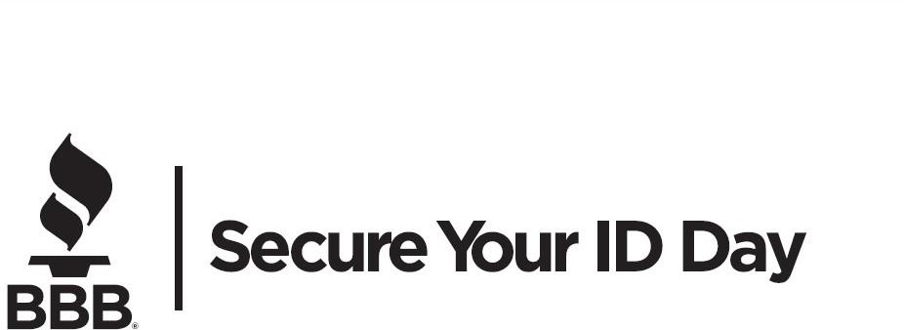

Volunteers are Needed!!!!!!
7:30 AM to 12:00
Assist with set-up, break-down;
off-loading customer boxes/bags;
assisting with Food Drive Collection

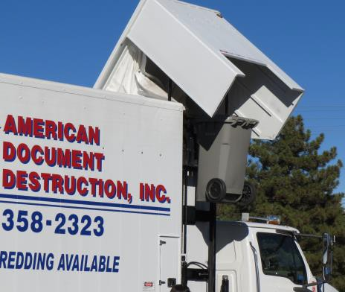
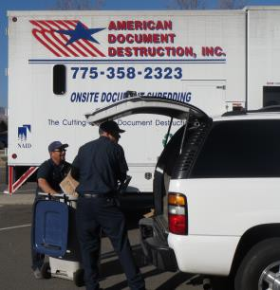
Date: October 16
Time: 9 am to 12 pm
(or until the shred trucks are full)

LOCATION:

Atlantis Casino Resort 3800 S Virginia St (west parking lot) Reno, NV 89502

We are hosting a food drive! Please bring a non-perishable food or cash donation to benefit the Food Bank of Northern Nevada.

This event made possible by our local partners:

American Document Destruction Atlantis Casino Resort
KTVN Channel 2 News AT&T Pioneers-Silver State Chapter
Nevada ranked 4th in Identity Theft Reports in 2020

What can you do?
Destroy documents that have information you don’t want getting into the hands of fraudsters.
Secure Your ID Day if a free event where you can safely and securely dispose of unneeded personal documents. Shredding trucks will be on-site accepting up to three (3) boxes of bags of unwanted documents to shred.
Put everything in your trunk, stay in your car and we will do the rest.
Secure your ID Day is a free event where you can safely and securely dispose of up to three (3) boxes or bags of unwanted personal documents. Mobile shredding trucks will be on site accepting up to three (3) boxes or bags of unwanted documents to shred.
Join us on
Saturday, October 16, 2021 for Secure Your ID Day!
Pioneers member benefit programs opportunity for your community, friends and family
Pioneers have a long-standing history of providing support in our communities. We do it through hands-on projects and by providing resources and opportunities to enhance one’s quality of life.
In an effort to build on the support we provide, Pioneers are happy to announce that our Affinity Partnerships and discounts are now additional resources and benefits that you can offer to your community partners, organizations, family members and friends.
We make a real difference in the communities we serve, and we want Pioneers' benefits to make a difference as well. Every time someone uses a Pioneers Affinity Partner link, in addition to receiving a great discount, they are also helping the Pioneers retain those Affinity Partner relationships which assists with overall support of the organization. To start sharing, please reference the website or links below.
Thank you for your continued support of Pioneers Affinity Partnerships.
Laura Whitlock
Interim Executive Director
Pioneers, a volunteer network
Pioneers Telecom Volunteers | Member Benefits | Partners Discounts
Program | Program Link | Value Proposition to Pioneers
Financial
LifeLock | https://www.lifelock.com/store?promocode=PIONEERSMEMBER | Pioneers get 35% off the first year of LifeLock
Insurance
Vision Service Plan (VSP) | https://www.vspdirect.com/pioneers/welcome | Pioneers save $235+ each year on eye care and eyewear
Travel
Avis** | https://www.avis.com/en/association/B291099 | Up to 25% off
Budget** | https://www.budget.com/en/association/R198199 | Up to 25% off
Collette | www.gocollette.com/pioneers | Pioneers can save up to $500 per person* on seasonal offers
Emergency Assistance | www.emergencyassistanceplus.com/TelecomPioneers | Pioneers discounted group rates
Hotel Engine** | www.hotelengine.com/join/piovol5 | Average savings of 26%
Orlando Vacation | Welcome - Orlando Employee Discounts | Pioneers can save up to 35% off their next vacation to Orlando
TNT/Funjet | https://www.funjet.com/default.aspx?plcode=pioneers&gsvendor=TPV | 5% member discount and “Price Match Plus”
Discounts
Life Line Screening | http://www.lifelinescreening.com/pioneers | Special discounted flat group rate. 4 screenings for $135, plus osteo for $10 more
Office Depot | http://officediscounts.org/pioneers/ | Pioneers can save up to 75% qualifying items
SCI - Neptune & Dignity | http://www.neptunesociety.com/cremation-prices | Pioneers receive an additional 10% off the standard pricing
 | https://tp.dignitymemorial.com/
LifeStation | https://www.lifestation.com/pioneers/ | Special Offer for Pioneers. Starting at $19.95/month.
Hear in America | http://www.hearinamerica.com/Pioneers | 30%-70%
Legal Shield** | https://w3.legalshield.com/gs/init?grp=pvn | Discounts vary
Long-Term Care | Planning Kit Call: 1-800-616-8759 | Discounts vary
MetLife Dental | MetLife TakeAlong Dental – Dental Insurance | Discounts vary
Nationwide Pet Insurance | TelecomPioneers (petinsurance.com) | Discounts vary
Simply Affordable Insurance | https://info.simplyaffordableinsurance.com/pioneers | Discounts vary
SingleCare | http://www.singlecare.com/pioneers | Discounts vary
Brookdale Communities | http://www.pioneersvolunteer.org/Pioneers/Members/Benefits_Details.aspx#/Brookdale | 7.5% off monthly fees
Santa Tours** | www.incontra.com
** Available to Canadian Pioneers

